MAD LAB RECORD
Submitted By: Tanisha Mathur
Reg. No.: 230953110
CCE: B, Roll No.: 17
LAB1: Introduction to Android
Q1. Create an Android application to show the demo of displaying text with justifying elements, changing text colors ,fonts etc.
activity_main.xml
<?xml version="1.0" encoding="utf-8"?>
<LinearLayout
xmlns:android="http://schemas.android.com/apk/res/android"
android:layout_width="match_parent"
android:layout_height="match_parent"
android:orientation="vertical"
android:padding="20dp">
<!-- Text Display -->
<TextView
android:id="@+id/textDemo"
android:layout_width="match_parent"
android:layout_height="wrap_content"
android:text="Hello! This is a demo app showing text formatting like color, font style, and alignment."
android:textSize="20sp"
android:textColor="#000000"
android:textAlignment="center"
android:padding="20dp"/>
<!-- Buttons -->
<Button
android:id="@+id/btnColor"
android:layout_width="match_parent"
android:layout_height="wrap_content"
android:text="Change Color"/>
<Button
android:id="@+id/btnSize"
android:layout_width="match_parent"
android:layout_height="wrap_content"
android:text="Change Size"/>
<Button
android:id="@+id/btnStyle"
android:layout_width="match_parent"
android:layout_height="wrap_content"
android:text="Change Font Style"/>
</LinearLayout>

MainActivity.java
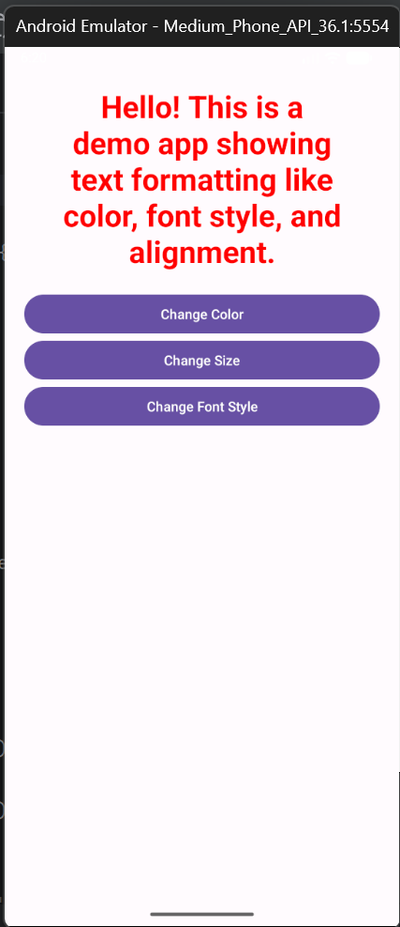
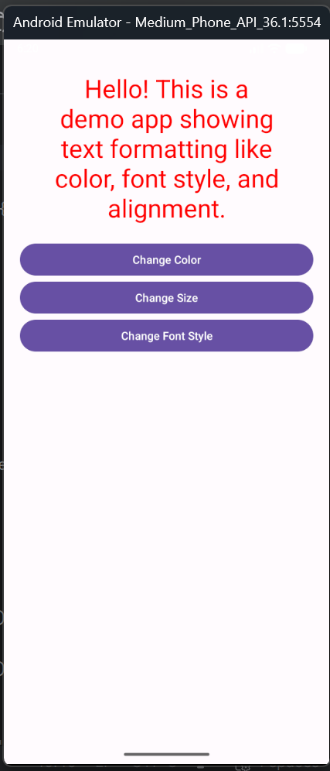
package com.example.lab1firstq;
import android.graphics.Color;
import android.graphics.Typeface;
import android.os.Bundle;
import android.view.View;
import android.widget.Button;
import android.widget.TextView;
import androidx.appcompat.app.AppCompatActivity;
public class MainActivity extends AppCompatActivity {
TextView textDemo;
int size = 20;
boolean bold = false;
@Override
protected void onCreate(Bundle savedInstanceState) {
super.onCreate(savedInstanceState);
setContentView(R.layout.activity_main);
textDemo = findViewById(R.id.textDemo);
Button btnColor = findViewById(R.id.btnColor);
Button btnSize = findViewById(R.id.btnSize);
Button btnStyle = findViewById(R.id.btnStyle);
// Change text color
btnColor.setOnClickListener(new View.OnClickListener() {
@Override
public void onClick(View v) {
textDemo.setTextColor(Color.RED);
}
});
// Change text size
btnSize.setOnClickListener(new View.OnClickListener() {
@Override
public void onClick(View v) {
size += 4;
textDemo.setTextSize(size);
}
});
// Change font style
btnStyle.setOnClickListener(new View.OnClickListener() {
@Override
public void onClick(View v) {
if (bold) {
textDemo.setTypeface(null, Typeface.NORMAL);
} else {
textDemo.setTypeface(null, Typeface.BOLD);
} bold = !bold;
}
});}
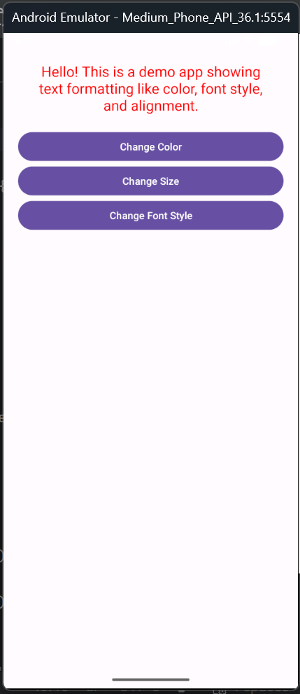

Q2. Find the “hello word” text in the XML document and modify the text.
activity_main.xml
<?xml version="1.0" encoding="utf-8"?>
<androidx.constraintlayout.widget.ConstraintLayout xmlns:android="http://schemas.android.com/apk/res/android"
xmlns:app="http://schemas.android.com/apk/res-auto"
xmlns:tools="http://schemas.android.com/tools"
android:id="@+id/main"
android:layout_width="match_parent"
android:layout_height="match_parent"
tools:context=".MainActivity">

<TextView
android:layout_width="wrap_content"
android:layout_height="wrap_content"
android:text="I have changed this text!"
android:textAlignment="gravity"
android:textColor="@color/white"
android:background="#fa48d0"
app:layout_constraintBottom_toBottomOf="parent"
app:layout_constraintEnd_toEndOf="parent"
app:layout_constraintStart_toStartOf="parent"
app:layout_constraintTop_toTopOf="parent"
tools:text="@tools:sample/cities" />

</androidx.constraintlayout.widget.ConstraintLayout>

MainActivity.java
package com.example.myapplication;
import android.os.Bundle;
import androidx.activity.EdgeToEdge;
import androidx.appcompat.app.AppCompatActivity;
import androidx.core.graphics.Insets;
import androidx.core.view.ViewCompat;
import androidx.core.view.WindowInsetsCompat;

public class MainActivity extends AppCompatActivity {

@Override
protected void onCreate(Bundle savedInstanceState) {
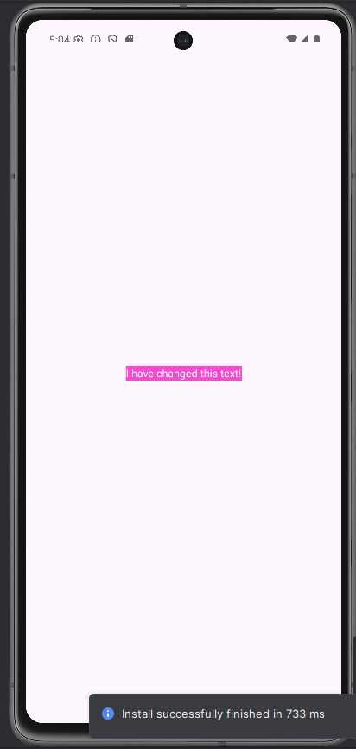
super.onCreate(savedInstanceState);
EdgeToEdge.enable(this);
setContentView(R.layout.activity_main);
ViewCompat.setOnApplyWindowInsetsListener(findViewById(R.id.main), (v, insets) -> {
Insets systemBars = insets.getInsets(WindowInsetsCompat.Type.systemBars());
v.setPadding(systemBars.left, systemBars.top, systemBars.right, systemBars.bottom);
return insets;
});
}
}

LAB 2: Introduction To Activity And Layouts In Android

Q1. Create an app that illustrates that the activity lifecycle method being triggered by various action. Understand when onCreate(),onStart(),onResume event occur.

Activity_main.xml
<?xml version="1.0" encoding="utf-8"?>
<androidx.constraintlayout.widget.ConstraintLayout xmlns:android="http://schemas.android.com/apk/res/android"
xmlns:app="http://schemas.android.com/apk/res-auto"
xmlns:tools="http://schemas.android.com/tools"
android:id="@+id/main"
android:layout_width="match_parent"
android:layout_height="match_parent"
android:background="@color/black"
tools:context=".MainActivity">

<TextView
android:layout_width="326dp"
android:layout_height="411dp"
android:text="Activity Lifecycle Demo"
android:textColor="#c4aef5"
android:textSize="80px"
android:textStyle="bold"
app:layout_constraintBottom_toBottomOf="parent"
app:layout_constraintEnd_toEndOf="parent"
app:layout_constraintHorizontal_bias="0.494"
app:layout_constraintStart_toStartOf="parent"
app:layout_constraintTop_toTopOf="parent"
app:layout_constraintVertical_bias="0.143" />

<TextView
android:id="@+id/textView2"
android:layout_width="326dp"
android:layout_height="411dp"
android:text="Lifecycle events are displayed as Toast notifications on the screen"
android:textColor="#f5aeae"
android:textSize="50px"
app:layout_constraintBottom_toBottomOf="parent"
app:layout_constraintEnd_toEndOf="parent"
app:layout_constraintHorizontal_bias="0.494"
app:layout_constraintStart_toStartOf="parent"
app:layout_constraintTop_toTopOf="parent"
app:layout_constraintVertical_bias="0.356" />

<TextView
android:layout_width="329dp"
android:layout_height="185dp"
android:text="Toast: Toast is used to display short, temporary pop-up messages on the screen. In this application, Toast messages are used to visually indicate when activity lifecycle methods such as onCreate(), onStart(), and onResume() are triggered."
android:textColor="#c3f5ae"
android:textSize="50px"
app:layout_constraintBottom_toBottomOf="parent"
app:layout_constraintEnd_toEndOf="parent"
app:layout_constraintHorizontal_bias="0.512"
app:layout_constraintStart_toStartOf="parent"
app:layout_constraintTop_toTopOf="parent"
app:layout_constraintVertical_bias="0.688" />

<TextView
android:id="@+id/textView"
android:layout_width="326dp"
android:layout_height="411dp"
android:text="Log: Log is used to display lifecycle-related messages in Logcat for debugging purposes. These log messages help developers track and analyze the sequence of activity lifecycle method calls and are not visible to the user."
android:textColor="#c3f5ae"
android:textSize="50px"
app:layout_constraintBottom_toBottomOf="parent"
app:layout_constraintEnd_toEndOf="parent"
app:layout_constraintHorizontal_bias="0.494"
app:layout_constraintStart_toStartOf="parent"
app:layout_constraintTop_toTopOf="parent"
app:layout_constraintVertical_bias="0.575" />

</androidx.constraintlayout.widget.ConstraintLayout>

MainActivity.java
package com.example.lab2q1;
import android.os.Bundle;
import android.util.Log;
import android.widget.Toast;
import androidx.appcompat.app.AppCompatActivity;
public class MainActivity extends AppCompatActivity {
private static final String TAG = "LifecycleDemo";
@Override
protected void onCreate(Bundle savedInstanceState) {
super.onCreate(savedInstanceState);
setContentView(R.layout.activity_main);
Log.d(TAG, "onCreate called");
Toast.makeText(this, "onCreate Called", Toast.LENGTH_SHORT).show();
}

@Override
protected void onStart() {
super.onStart();
Log.d(TAG, "onStart called");
Toast.makeText(this, "onStart Called", Toast.LENGTH_SHORT).show();
}

@Override
protected void onResume() {
super.onResume();
Log.d(TAG, "onResume called");
Toast.makeText(this, "onResume Called", Toast.LENGTH_SHORT).show();
}

@Override
protected void onPause() {
super.onPause();
Log.d(TAG, "onPause called");
Toast.makeText(this, "onPause Called", Toast.LENGTH_SHORT).show();
}

@Override
protected void onStop() {
super.onStop();
Log.d(TAG, "onStop called");
Toast.makeText(this, "onStop Called", Toast.LENGTH_SHORT).show();
}

@Override
protected void onRestart() {
super.onRestart();
Log.d(TAG, "onRestart called");
Toast.makeText(this, "onRestart Called", Toast.LENGTH_SHORT).show();
}

@Override
protected void onDestroy() {
super.onDestroy();
Log.d(TAG, "onDestroy called");
Toast.makeText(this, "onDestroy Called", Toast.LENGTH_SHORT).show();
}
}

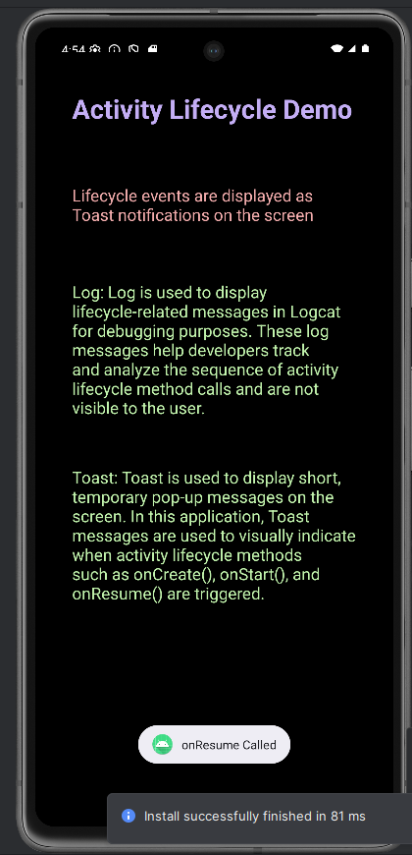
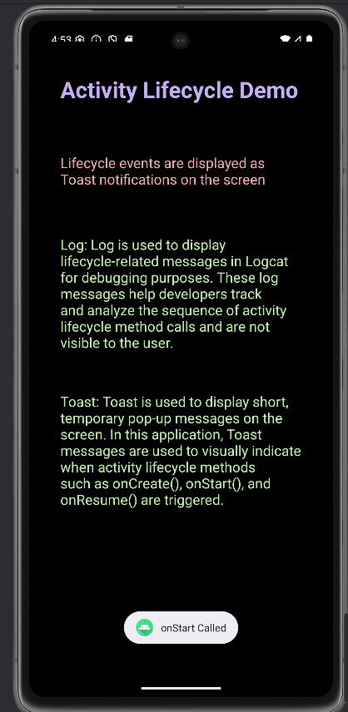
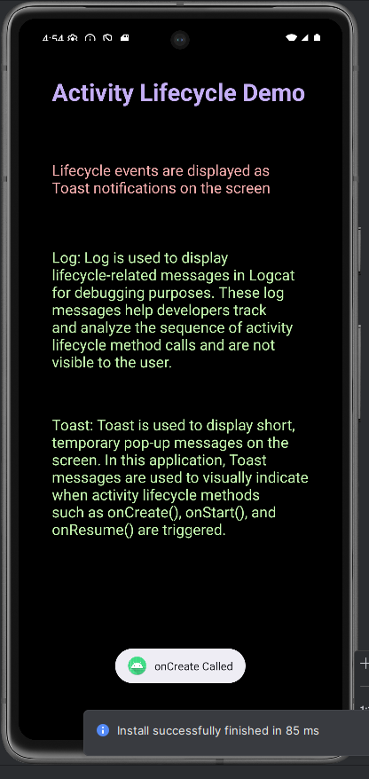

Q2. Create a Calculator app that does the function of multiplication, addition, division, subtraction but displays the result in the format of:-Num1 operator num2 = result. Back button on the next activity should get back to the calculator activity again.

activity_main.xml
<?xml version="1.0" encoding="utf-8"?>
<LinearLayout
xmlns:android="http://schemas.android.com/apk/res/android"
android:layout_width="match_parent"
android:layout_height="match_parent"
android:orientation="vertical"
android:padding="20dp">
<EditText
android:id="@+id/num1"
android:layout_width="match_parent"
android:layout_height="wrap_content"
android:hint="Enter Number 1"
android:inputType="numberDecimal"/>
<EditText
android:id="@+id/num2"
android:layout_width="match_parent"
android:layout_height="wrap_content"
android:hint="Enter Number 2"
android:inputType="numberDecimal"/>
<Button
android:id="@+id/btnAdd"
android:layout_width="match_parent"
android:layout_height="wrap_content"
android:text="Add"/>
<Button
android:id="@+id/btnSub"
android:layout_width="match_parent"
android:layout_height="wrap_content"
android:text="Subtract"/>
<Button
android:id="@+id/btnMul"
android:layout_width="match_parent"
android:layout_height="wrap_content"
android:text="Multiply"/>
<Button
android:id="@+id/btnDiv"
android:layout_width="match_parent"
android:layout_height="wrap_content"
android:text="Divide"/>
</LinearLayout>
activity_result.xml
<?xml version="1.0" encoding="utf-8"?>
<LinearLayout
xmlns:android="http://schemas.android.com/apk/res/android"
android:layout_width="match_parent"
android:layout_height="match_parent"
android:gravity="center"
android:orientation="vertical">
<TextView
android:id="@+id/resultText"
android:layout_width="wrap_content"
android:layout_height="wrap_content"
android:textSize="24sp"/>
<Button
android:id="@+id/btnBack"
android:layout_width="wrap_content"
android:layout_height="wrap_content"
android:text="Back"/>
</LinearLayout>
MainActivity.java
package com.example.lab2q2calci;
import android.content.Intent;
import android.os.Bundle;
import android.view.View;
import android.widget.Button;
import android.widget.EditText;
import androidx.appcompat.app.AppCompatActivity;
public class MainActivity extends AppCompatActivity {
EditText num1, num2;
@Override
protected void onCreate(Bundle savedInstanceState) {
super.onCreate(savedInstanceState);
setContentView(R.layout.activity_main);
num1 = findViewById(R.id.num1);
num2 = findViewById(R.id.num2);
Button btnAdd = findViewById(R.id.btnAdd);
Button btnSub = findViewById(R.id.btnSub);
Button btnMul = findViewById(R.id.btnMul);
Button btnDiv = findViewById(R.id.btnDiv);
btnAdd.setOnClickListener(v -> calculate("+"));
btnSub.setOnClickListener(v -> calculate("-"));
btnMul.setOnClickListener(v -> calculate("*"));
btnDiv.setOnClickListener(v -> calculate("/"));
}
private void calculate(String operator) {
double n1 = Double.parseDouble(num1.getText().toString());
double n2 = Double.parseDouble(num2.getText().toString());
double result = 0;
switch (operator) {
case "+": result = n1 + n2; break;
case "-": result = n1 - n2; break;
case "*": result = n1 * n2; break;
case "/": result = n1 / n2; break;
}
String output = n1 + " " + operator + " " + n2 + " = " + result;
Intent intent = new Intent(MainActivity.this, ResultActivity.class);
intent.putExtra("result", output);
startActivity(intent);
}
}
ResultActivity.java
package com.example.lab2q2calci;
import android.widget.Button;
import android.os.Bundle;
import android.widget.TextView;
import androidx.appcompat.app.AppCompatActivity;
public class ResultActivity extends AppCompatActivity {
@Override
protected void onCreate(Bundle savedInstanceState) {
super.onCreate(savedInstanceState);
setContentView(R.layout.activity_result);
TextView resultText = findViewById(R.id.resultText);
String result = getIntent().getStringExtra("result");
resultText.setText(result);
Button btnBack = findViewById(R.id.btnBack);
btnBack.setOnClickListener(v -> finish());
}
}

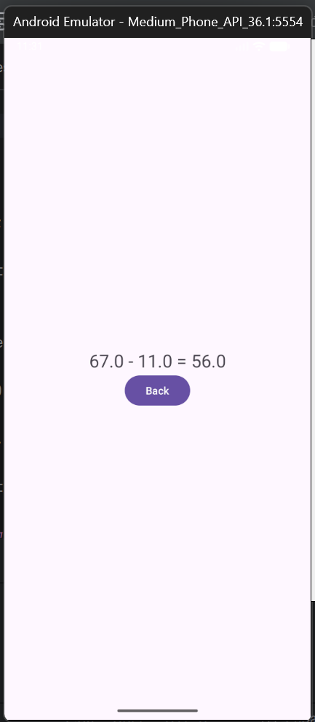
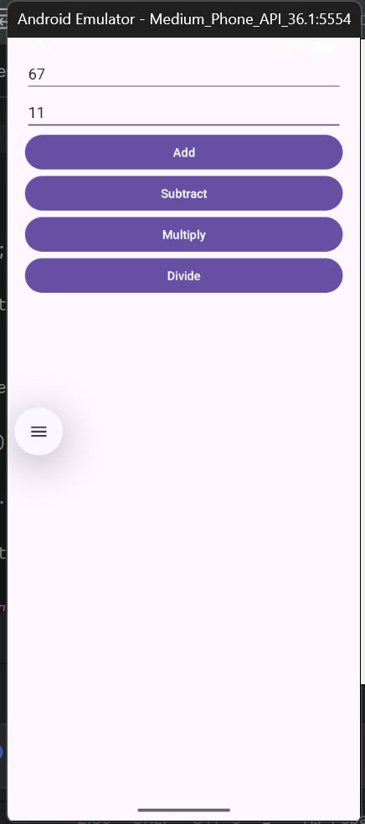

Q3. Create the following given scenario using linear and relative layout concept.
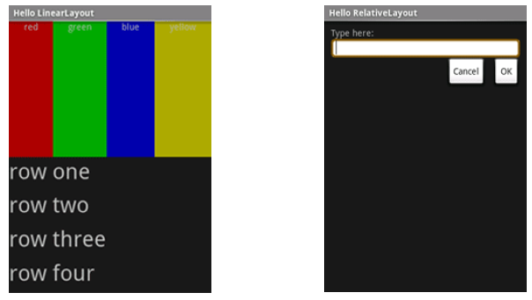

activity_main.xml

<?xml version="1.0" encoding="utf-8"?>
<androidx.constraintlayout.widget.ConstraintLayout xmlns:android="http://schemas.android.com/apk/res/android"
xmlns:app="http://schemas.android.com/apk/res-auto"
xmlns:tools="http://schemas.android.com/tools"
android:id="@+id/main"
android:layout_width="match_parent"
android:layout_height="match_parent"
tools:context=".MainActivity">

<TextView
android:layout_width="wrap_content"
android:layout_height="wrap_content"
android:text="Hello World!"
app:layout_constraintBottom_toBottomOf="parent"
app:layout_constraintEnd_toEndOf="parent"
app:layout_constraintStart_toStartOf="parent"
app:layout_constraintTop_toTopOf="parent" />

</androidx.constraintlayout.widget.ConstraintLayout>

activity_relative.xml

<?xml version="1.0" encoding="utf-8"?>
<RelativeLayout xmlns:android="http://schemas.android.com/apk/res/android"
android:layout_width="match_parent"
android:layout_height="match_parent"
android:background="#111111"
android:padding="16dp">

<TextView
android:id="@+id/tvLabel"
android:layout_width="wrap_content"
android:layout_height="wrap_content"
android:text="Type here:"
android:textColor="#FFFFFF"
android:textSize="16sp" />

<EditText
android:id="@+id/editText"
android:layout_width="match_parent"
android:layout_height="wrap_content"
android:layout_below="@id/tvLabel"
android:layout_marginTop="8dp"
android:background="@android:drawable/edit_text"
android:padding="8dp" />

<Button
android:id="@+id/btnCancel"
android:layout_width="wrap_content"
android:layout_height="wrap_content"
android:text="Cancel"
android:layout_below="@id/editText"
android:layout_marginTop="12dp"
android:layout_alignParentEnd="true"
android:layout_marginEnd="80dp" />

<Button
android:id="@+id/btnOk"
android:layout_width="wrap_content"
android:layout_height="wrap_content"
android:text="OK"
android:layout_below="@id/editText"
android:layout_marginTop="12dp"
android:layout_alignParentEnd="true" />

</RelativeLayout>

activity_linear.xml

<?xml version="1.0" encoding="utf-8"?>
<LinearLayout xmlns:android="http://schemas.android.com/apk/res/android"
android:layout_width="match_parent"
android:layout_height="match_parent"
android:orientation="vertical"
android:background="#000000">

<!-- Top horizontal color bar -->
<LinearLayout
android:layout_width="match_parent"
android:layout_height="120dp"
android:orientation="horizontal">
<TextView
android:layout_width="0dp"
android:layout_height="match_parent"
android:layout_weight="1"
android:background="#FF0000"
android:gravity="center"
android:text="red"
android:textColor="#FFFFFF" />
<TextView
android:layout_width="0dp"
android:layout_height="match_parent"
android:layout_weight="1"
android:background="#00FF00"
android:gravity="center"
android:text="green"
android:textColor="#FFFFFF" />
<TextView
android:layout_width="0dp"
android:layout_height="match_parent"
android:layout_weight="1"
android:background="#0000FF"
android:gravity="center"
android:text="blue"
android:textColor="#FFFFFF" />
<TextView
android:layout_width="0dp"
android:layout_height="match_parent"
android:layout_weight="1"
android:background="#CCCC00"
android:gravity="center"
android:text="yellow"
android:textColor="#FFFFFF" />
</LinearLayout>

<!-- Rows -->
<TextView
android:layout_width="wrap_content"
android:layout_height="wrap_content"
android:text="row one"
android:textColor="#FFFFFF"
android:textSize="24sp"
android:padding="10dp" />
<TextView
android:layout_width="wrap_content"
android:layout_height="wrap_content"
android:text="row two"
android:textColor="#FFFFFF"
android:textSize="24sp"
android:padding="10dp" />
<TextView
android:layout_width="wrap_content"
android:layout_height="wrap_content"
android:text="row three"
android:textColor="#FFFFFF"
android:textSize="24sp"
android:padding="10dp" />
<TextView
android:layout_width="wrap_content"
android:layout_height="wrap_content"
android:text="row four"
android:textColor="#FFFFFF"
android:textSize="24sp"
android:padding="10dp" />
</LinearLayout>

MainActivity.java

package com.example.lab2q3;
import android.os.Bundle;
import androidx.activity.EdgeToEdge;
import androidx.appcompat.app.AppCompatActivity;
import androidx.core.graphics.Insets;
import androidx.core.view.ViewCompat;
import androidx.core.view.WindowInsetsCompat;
public class MainActivity extends AppCompatActivity {
@Override
protected void onCreate(Bundle savedInstanceState) {
super.onCreate(savedInstanceState);
setContentView(R.layout.activity_relative); // for linear : setContentView(R.layout.activity_linear);
}
}
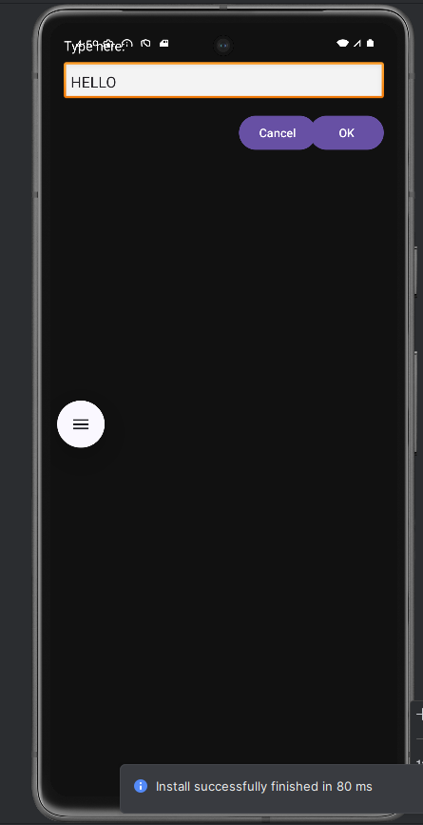
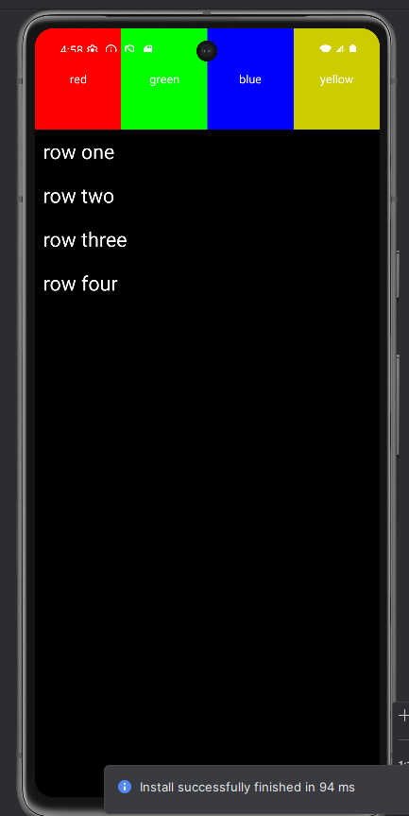

Q4. Create an app such that when the user click on the given URL typed by the user, it visits the corresponding page.
activity_main.xml
<?xml version="1.0" encoding="utf-8"?>
<LinearLayout xmlns:android="http://schemas.android.com/apk/res/android"
android:id="@+id/main"
android:layout_width="match_parent"
android:layout_height="match_parent"
android:orientation="vertical"
android:padding="16dp">
<TextView
android:layout_width="wrap_content"
android:layout_height="wrap_content"
android:text="Enter URL:"
android:textSize="18sp"/>
<EditText
android:id="@+id/editUrl"
android:layout_width="match_parent"
android:layout_height="wrap_content"
android:hint="https://www.google.com"
android:inputType="textUri"/>
<Button
android:id="@+id/btnOpen"
android:layout_width="wrap_content"
android:layout_height="wrap_content"
android:text="Open URL"
android:layout_marginTop="12dp"/>
</LinearLayout>

MainActivity.java

package com.example.lab2q4;
import android.content.Intent;
import android.net.Uri;
import android.os.Bundle;
import android.view.View;
import android.widget.Button;
import android.widget.EditText;
import android.widget.Toast;
import androidx.appcompat.app.AppCompatActivity;
public class MainActivity extends AppCompatActivity {
EditText editUrl;
Button btnOpen;
@Override
protected void onCreate(Bundle savedInstanceState) {
super.onCreate(savedInstanceState);
setContentView(R.layout.activity_main);
editUrl = findViewById(R.id.editUrl);
btnOpen = findViewById(R.id.btnOpen);
btnOpen.setOnClickListener(new View.OnClickListener() {
@Override
public void onClick(View v) {
String url = editUrl.getText().toString().trim();
if (!url.startsWith("http://") && !url.startsWith("https://")) {
url = "https://" + url;
}
if (!url.isEmpty()) {
Intent intent = new Intent(Intent.ACTION_VIEW, Uri.parse(url));
startActivity(intent);
} else {
Toast.makeText(MainActivity.this, "Please enter a URL", Toast.LENGTH_SHORT).show();
}
}
});
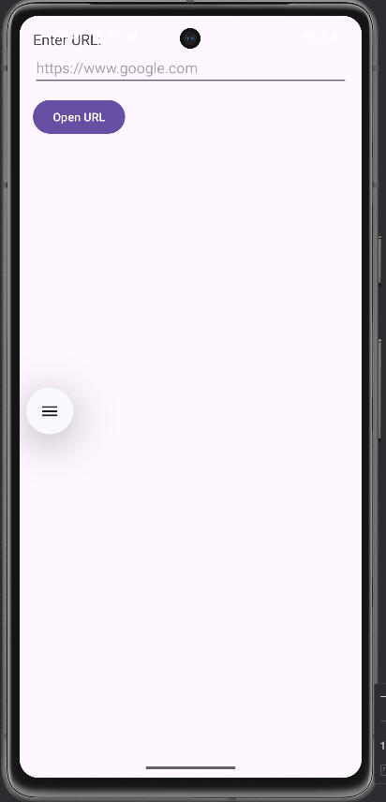
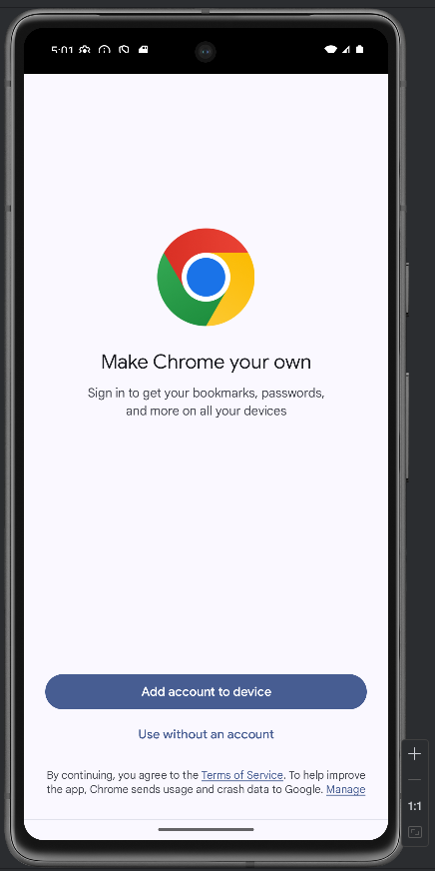
} }
LAB 3: Activity And Layout continued
Q1. Using given scenario develop an application to perform following layout operations
▪ List view
▪ Grid view
▪ Tab layout
▪ Table layout

activity_main.xml

<?xml version="1.0" encoding="utf-8"?>
<LinearLayout xmlns:android="http://schemas.android.com/apk/res/android"
xmlns:app="http://schemas.android.com/apk/res-auto"
android:layout_width="match_parent"
android:layout_height="match_parent"
android:orientation="vertical"
android:background="#fcc2ce"
>
<com.google.android.material.tabs.TabLayout
android:id="@+id/tabLayout"
android:layout_width="match_parent"
android:layout_height="wrap_content"/>
<androidx.viewpager2.widget.ViewPager2
android:id="@+id/viewPager"
android:layout_width="match_parent"
android:layout_height="match_parent"/>
</LinearLayout>

fragment_list.xml

<ListView xmlns:android="http://schemas.android.com/apk/res/android"
android:id="@+id/listView"
android:layout_width="match_parent"
android:layout_height="match_parent"
android:textColor="#FFFFFF"
/>

fragment_grid.xml

<GridView xmlns:android="http://schemas.android.com/apk/res/android"
android:id="@+id/gridView"
android:layout_width="match_parent"
android:layout_height="match_parent"
android:numColumns="3"
android:horizontalSpacing="8dp"
android:verticalSpacing="8dp"
android:padding="8dp"
android:textColor="#FFFFFF" />

fragment_table.xml

<TableLayout xmlns:android="http://schemas.android.com/apk/res/android"
android:id="@+id/tableLayout"
android:layout_width="match_parent"
android:layout_height="match_parent"
android:stretchColumns="1"
android:padding="12dp"
android:textColor="#FFFFFF">

<TableRow>
<TextView
android:text="Open..."
android:textSize="16sp"
android:padding="12dp" />

<TextView
android:text="Ctrl+O"
android:textSize="14sp"
android:gravity="end"
android:padding="12dp" />
</TableRow>

<TableRow>
<TextView
android:text="Save..."
android:textSize="16sp"
android:padding="12dp" />

<TextView
android:text="Ctrl+S"
android:textSize="14sp"
android:gravity="end"
android:padding="12dp" />
</TableRow>

<TableRow>
<TextView
android:text="Save As..."
android:textSize="16sp"
android:padding="12dp" />

<TextView
android:text="Ctrl+Shift+S"
android:textSize="14sp"
android:gravity="end"
android:padding="12dp" />
</TableRow>

<TableRow>
<TextView
android:text="Import..."
android:textSize="16sp"
android:padding="12dp" />

<TextView
android:text="Ctrl+I"
android:textSize="14sp"
android:gravity="end"
android:padding="12dp" />
</TableRow>

<TableRow>
<TextView
android:text="Export..."
android:textSize="16sp"
android:padding="12dp" />

<TextView
android:text="Ctrl+E"
android:textSize="14sp"
android:gravity="end"
android:padding="12dp" />
</TableRow>

<TableRow>
<TextView
android:text="Quit"
android:textSize="16sp"
android:padding="12dp" />

<TextView
android:text=""
android:padding="12dp" />
</TableRow>

</TableLayout>

MainActivity.java

package com.example.lab3q1;

import android.os.Bundle;
import androidx.appcompat.app.AppCompatActivity;
import com.google.android.material.tabs.TabLayout;
import com.google.android.material.tabs.TabLayoutMediator;
import androidx.viewpager2.widget.ViewPager2;

public class MainActivity extends AppCompatActivity {

TabLayout tabLayout;
ViewPager2 viewPager;

@Override
protected void onCreate(Bundle savedInstanceState) {
super.onCreate(savedInstanceState);
setContentView(R.layout.activity_main);

tabLayout = findViewById(R.id.tabLayout);
viewPager = findViewById(R.id.viewPager);

ViewPagerAdapter adapter = new ViewPagerAdapter(this);
viewPager.setAdapter(adapter);

new TabLayoutMediator(tabLayout, viewPager,
(tab, position) -> {
if (position == 0) tab.setText("ListView");
if (position == 1) tab.setText("GridView");
if (position == 2) tab.setText("Table");
}).attach();
}
}

ViewPagerAdapter.java

package com.example.lab3q1;

import androidx.annotation.NonNull;
import androidx.fragment.app.Fragment;
import androidx.fragment.app.FragmentActivity;
import androidx.viewpager2.adapter.FragmentStateAdapter;

public class ViewPagerAdapter extends FragmentStateAdapter {

public ViewPagerAdapter(@NonNull FragmentActivity fa) {
super(fa);
}

@NonNull
@Override
public Fragment createFragment(int position) {
if (position == 0) return new ListFragment();
if (position == 1) return new GridFragment();
return new TableFragment();
}

@Override
public int getItemCount() {
return 3;
}
}

ListFragment.java

package com.example.lab3q1;

import android.os.Bundle;
import android.view.*;
import android.widget.*;
import androidx.fragment.app.Fragment;

public class ListFragment extends Fragment {

String[] countries = {
"American Samoa","El Salvador","Saint Helena",
"Saint Kitts and Nevis","Saint Lucia",
"Saint Pierre and Miquelon",
"Saint Vincent and the Grenadines",
"Samoa","San Marino","Saudi Arabia"
};

@Override
public View onCreateView(LayoutInflater inflater, ViewGroup container,
Bundle savedInstanceState) {
View v = inflater.inflate(R.layout.fragment_list, container, false);
ListView listView = v.findViewById(R.id.listView);

ArrayAdapter<String> adapter =
new ArrayAdapter<>(getActivity(),
android.R.layout.simple_list_item_1, countries);

listView.setAdapter(adapter);
return v;
}
}

GridFragment.java

package com.example.lab3q1;

import android.os.Bundle;
import android.view.LayoutInflater;
import android.view.View;
import android.view.ViewGroup;
import android.widget.GridView;

import androidx.fragment.app.Fragment;

public class GridFragment extends Fragment {

int[] images = {
R.drawable.dog1, R.drawable.dog2,
R.drawable.dog3, R.drawable.dog4,
R.drawable.dog5, R.drawable.dog6,
R.drawable.dog1, R.drawable.dog2,
R.drawable.dog3, R.drawable.dog4,
R.drawable.dog5, R.drawable.dog6,
R.drawable.dog1, R.drawable.dog2,
R.drawable.dog3, R.drawable.dog4,
R.drawable.dog5, R.drawable.dog6,
R.drawable.dog1, R.drawable.dog2,
R.drawable.dog3, R.drawable.dog4,
R.drawable.dog5, R.drawable.dog6,
};

@Override
public View onCreateView(LayoutInflater inflater, ViewGroup container,
Bundle savedInstanceState) {

View v = inflater.inflate(R.layout.fragment_grid, container, false);
GridView gridView = v.findViewById(R.id.gridView);

ImageAdapter adapter = new ImageAdapter(getActivity(), images);
gridView.setAdapter(adapter);
return v;
}
}

ImageAdapter.java

package com.example.lab3q1;

import android.content.Context;
import android.view.*;
import android.widget.*;
public class ImageAdapter extends BaseAdapter {

Context context;
int[] images;

public ImageAdapter(Context c, int[] imgs) {
context = c;
images = imgs;
}

@Override
public int getCount() { return images.length; }

@Override
public Object getItem(int i) { return images[i]; }

@Override
public long getItemId(int i) { return i; }

@Override
public View getView(int i, View view, ViewGroup parent) {
ImageView img;
if (view == null) {
img = new ImageView(context);
img.setLayoutParams(new GridView.LayoutParams(250, 250));
img.setScaleType(ImageView.ScaleType.CENTER_CROP);
} else {
img = (ImageView) view;
}
img.setImageResource(images[i]);
return img;
}
}

TableFragment.java

package com.example.lab3q1;

import android.os.Bundle;
import android.view.LayoutInflater;
import android.view.View;
import android.view.ViewGroup;
import android.widget.TableLayout;
import android.widget.TableRow;
import android.widget.TextView;
import androidx.fragment.app.Fragment;
public class TableFragment extends Fragment {
@Override
public View onCreateView(LayoutInflater inflater, ViewGroup container,
Bundle savedInstanceState) {

View v = inflater.inflate(R.layout.fragment_table, container, false);
TableLayout tableLayout = v.findViewById(R.id.tableLayout);
return v;
}
}
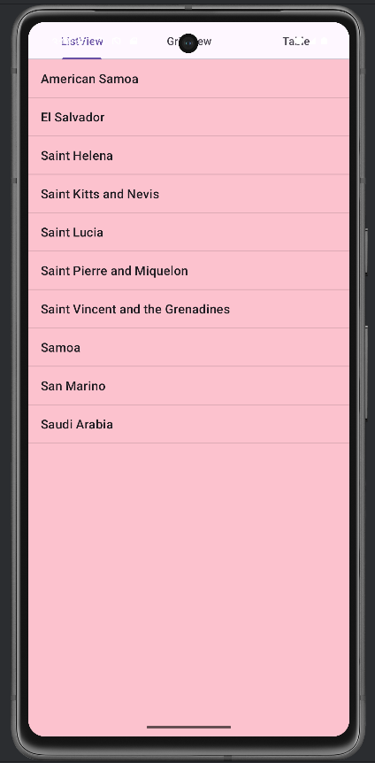
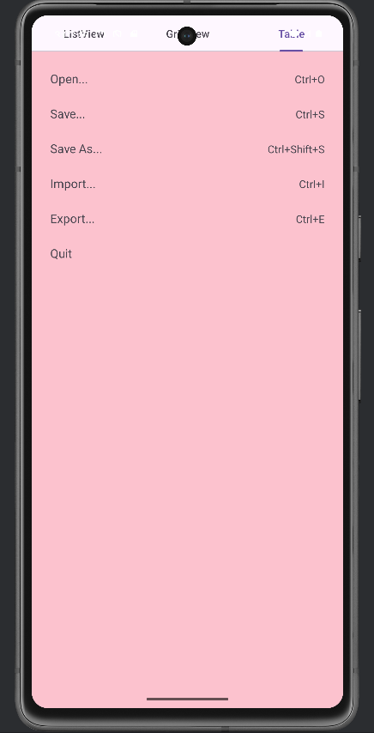
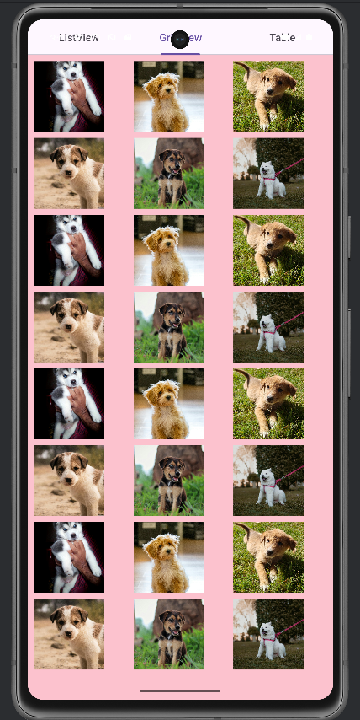

Q2. Write a program to list different sports, and when a sport is selected, display a message showing the selected sport.

activity_main.xml

<?xml version="1.0" encoding="utf-8"?>
<LinearLayout xmlns:android="http://schemas.android.com/apk/res/android"
android:layout_width="match_parent"
android:layout_height="match_parent"
android:orientation="vertical"
android:padding="16dp"
android:background="#ccdbfc">

<TextView
android:layout_width="match_parent"
android:layout_height="wrap_content"
android:text="Select a Sport"
android:textSize="20sp"
android:paddingBottom="8dp"/>

<ListView
android:id="@+id/listViewSports"
android:layout_width="match_parent"
android:layout_height="match_parent"/>
</LinearLayout>

MainActivity.java

package com.example.lab3q2;

import android.os.Bundle;
import android.widget.ArrayAdapter;
import android.widget.ListView;
import android.widget.Toast;
import androidx.appcompat.app.AppCompatActivity;

public class MainActivity extends AppCompatActivity {

ListView listView;
String[] sports = {
"Cricket",
"Football",
"Basketball",
"Hockey",
"Tennis",
"Badminton",
"Volleyball"
};
@Override
protected void onCreate(Bundle savedInstanceState) {
super.onCreate(savedInstanceState);
setContentView(R.layout.activity_main);
listView = findViewById(R.id.listViewSports);
ArrayAdapter<String> adapter = new ArrayAdapter<>(
this,
android.R.layout.simple_list_item_1,
sports
);
listView.setAdapter(adapter);

listView.setOnItemClickListener((parent, view, position, id) -> {
String selectedSport = sports[position];
Toast.makeText(MainActivity.this,
"You selected: " + selectedSport,
Toast.LENGTH_SHORT).show();
});
}
}

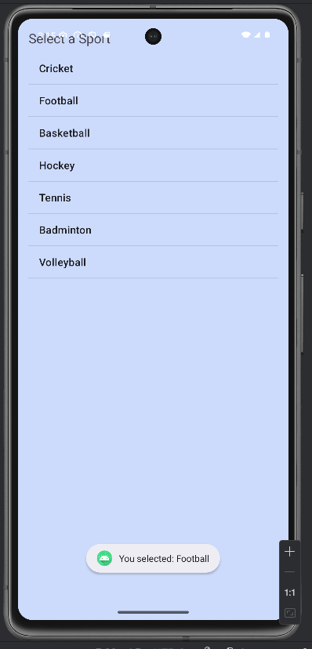
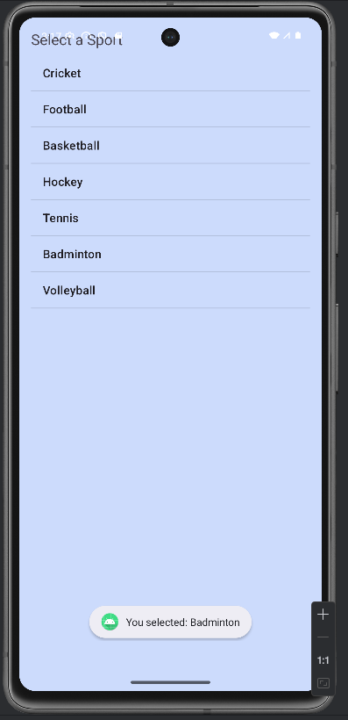

Q3. Design an news application and implement the navigation between sections like Top Stories, Sports, and Entertainment using tab layout.

activity_main.xml

<?xml version="1.0" encoding="utf-8"?>
<LinearLayout
xmlns:android="http://schemas.android.com/apk/res/android"
xmlns:app="http://schemas.android.com/apk/res-auto"
android:orientation="vertical"
android:layout_width="match_parent"
android:layout_height="match_parent"
android:background="#dbf0ff">

<com.google.android.material.tabs.TabLayout
android:id="@+id/tabLayout"
android:layout_width="match_parent"
android:layout_height="wrap_content"
app:tabIndicatorColor="@color/black"
app:tabTextColor="@color/black"
app:tabSelectedTextColor="@color/black"/>

<androidx.viewpager2.widget.ViewPager2
android:id="@+id/viewPager"
android:layout_width="match_parent"
android:layout_height="match_parent"/>

</LinearLayout>

fragment_top_stories.xml

<ScrollView xmlns:android="http://schemas.android.com/apk/res/android"
android:layout_width="match_parent"
android:layout_height="match_parent"
android:padding="12dp">

<LinearLayout
android:orientation="vertical"
android:layout_width="match_parent"
android:layout_height="wrap_content">

<ImageView
android:src="@drawable/top_news"
android:layout_width="match_parent"
android:layout_height="200dp"
android:scaleType="centerCrop"
android:layout_marginBottom="12dp"/>

<TextView
android:text="Breaking: Markets Rally After Budget Announcement"
android:textStyle="bold"
android:textSize="18sp"
android:layout_marginBottom="4dp"
android:layout_width="match_parent"
android:layout_height="wrap_content"/>

<TextView
android:text="Stocks surged today as investors reacted positively to the new economic policy..."
android:textSize="14sp"
android:layout_marginBottom="16dp"
android:layout_width="match_parent"
android:layout_height="wrap_content"/>
<TextView
android:text="Breaking: Markets Rally After Budget Announcement"
android:textStyle="bold"
android:textSize="18sp"
android:layout_marginBottom="4dp"
android:layout_width="match_parent"
android:layout_height="wrap_content"/>

<TextView
android:text="Stocks surged today as investors reacted positively to the new economic policy..."
android:textSize="14sp"
android:layout_marginBottom="16dp"
android:layout_width="match_parent"
android:layout_height="wrap_content"/>
<TextView
android:text="Breaking: Markets Rally After Budget Announcement"
android:textStyle="bold"
android:textSize="18sp"
android:layout_marginBottom="4dp"
android:layout_width="match_parent"
android:layout_height="wrap_content"/>

<TextView
android:text="Stocks surged today as investors reacted positively to the new economic policy..."
android:textSize="14sp"
android:layout_marginBottom="16dp"
android:layout_width="match_parent"
android:layout_height="wrap_content"/>
<TextView
android:text="Breaking: Markets Rally After Budget Announcement"
android:textStyle="bold"
android:textSize="18sp"
android:layout_marginBottom="4dp"
android:layout_width="match_parent"
android:layout_height="wrap_content"/>

<TextView
android:text="Stocks surged today as investors reacted positively to the new economic policy..."
android:textSize="14sp"
android:layout_marginBottom="16dp"
android:layout_width="match_parent"
android:layout_height="wrap_content"/>
<TextView
android:text="Breaking: Markets Rally After Budget Announcement"
android:textStyle="bold"
android:textSize="18sp"
android:layout_marginBottom="4dp"
android:layout_width="match_parent"
android:layout_height="wrap_content"/>

<TextView
android:text="Stocks surged today as investors reacted positively to the new economic policy..."
android:textSize="14sp"
android:layout_marginBottom="16dp"
android:layout_width="match_parent"
android:layout_height="wrap_content"/>
<TextView
android:text="Breaking: Markets Rally After Budget Announcement"
android:textStyle="bold"
android:textSize="18sp"
android:layout_marginBottom="4dp"
android:layout_width="match_parent"
android:layout_height="wrap_content"/>

<TextView
android:text="Stocks surged today as investors reacted positively to the new economic policy..."
android:textSize="14sp"
android:layout_marginBottom="16dp"
android:layout_width="match_parent"
android:layout_height="wrap_content"/>

</LinearLayout>
</ScrollView>

fragment_sports.xml

<ScrollView xmlns:android="http://schemas.android.com/apk/res/android"
android:layout_width="match_parent"
android:layout_height="match_parent"
android:padding="12dp">

<LinearLayout
android:orientation="vertical"
android:layout_width="match_parent"
android:layout_height="wrap_content">

<ImageView
android:src="@drawable/sports_news"
android:layout_width="match_parent"
android:layout_height="200dp"
android:scaleType="centerCrop"
android:layout_marginBottom="12dp"/>

<TextView
android:text="Cricket: India Wins Thrilling Final"
android:textStyle="bold"
android:textSize="18sp"
android:layout_marginBottom="4dp"
android:layout_width="match_parent"
android:layout_height="wrap_content"/>

<TextView
android:text="In a nail-biting finish, India chased the target in the last over..."
android:textSize="14sp"
android:layout_marginBottom="16dp"
android:layout_width="match_parent"
android:layout_height="wrap_content"/>
<TextView
android:text="Cricket: India Wins Thrilling Final"
android:textStyle="bold"
android:textSize="18sp"
android:layout_marginBottom="4dp"
android:layout_width="match_parent"
android:layout_height="wrap_content"/>

<TextView
android:text="In a nail-biting finish, India chased the target in the last over..."
android:textSize="14sp"
android:layout_marginBottom="16dp"
android:layout_width="match_parent"
android:layout_height="wrap_content"/>
<TextView
android:text="Cricket: India Wins Thrilling Final"
android:textStyle="bold"
android:textSize="18sp"
android:layout_marginBottom="4dp"
android:layout_width="match_parent"
android:layout_height="wrap_content"/>

<TextView
android:text="In a nail-biting finish, India chased the target in the last over..."
android:textSize="14sp"
android:layout_marginBottom="16dp"
android:layout_width="match_parent"
android:layout_height="wrap_content"/>
<TextView
android:text="Cricket: India Wins Thrilling Final"
android:textStyle="bold"
android:textSize="18sp"
android:layout_marginBottom="4dp"
android:layout_width="match_parent"
android:layout_height="wrap_content"/>

<TextView
android:text="In a nail-biting finish, India chased the target in the last over..."
android:textSize="14sp"
android:layout_marginBottom="16dp"
android:layout_width="match_parent"
android:layout_height="wrap_content"/>
<TextView
android:text="Cricket: India Wins Thrilling Final"
android:textStyle="bold"
android:textSize="18sp"
android:layout_marginBottom="4dp"
android:layout_width="match_parent"
android:layout_height="wrap_content"/>

<TextView
android:text="In a nail-biting finish, India chased the target in the last over..."
android:textSize="14sp"
android:layout_marginBottom="16dp"
android:layout_width="match_parent"
android:layout_height="wrap_content"/>
<TextView
android:text="Cricket: India Wins Thrilling Final"
android:textStyle="bold"
android:textSize="18sp"
android:layout_marginBottom="4dp"
android:layout_width="match_parent"
android:layout_height="wrap_content"/>

<TextView
android:text="In a nail-biting finish, India chased the target in the last over..."
android:textSize="14sp"
android:layout_marginBottom="16dp"
android:layout_width="match_parent"
android:layout_height="wrap_content"/>

</LinearLayout>
</ScrollView>

fragment_entertainment.xml

<ScrollView xmlns:android="http://schemas.android.com/apk/res/android"
android:layout_width="match_parent"
android:layout_height="match_parent"
android:padding="12dp">

<LinearLayout
android:orientation="vertical"
android:layout_width="match_parent"
android:layout_height="wrap_content">

<ImageView
android:src="@drawable/entertainment"
android:layout_width="match_parent"
android:layout_height="200dp"
android:scaleType="centerCrop"
android:layout_marginBottom="12dp"/>

<TextView
android:text="Movie Review: Sci-Fi Thriller Breaks Records"
android:textStyle="bold"
android:textSize="18sp"
android:layout_marginBottom="4dp"
android:layout_width="match_parent"
android:layout_height="wrap_content"/>

<TextView
android:text="The new release has stunned audiences with its visuals and story..."
android:textSize="14sp"
android:layout_marginBottom="16dp"
android:layout_width="match_parent"
android:layout_height="wrap_content"/>
<TextView
android:text="Movie Review: Sci-Fi Thriller Breaks Records"
android:textStyle="bold"
android:textSize="18sp"
android:layout_marginBottom="4dp"
android:layout_width="match_parent"
android:layout_height="wrap_content"/>

<TextView
android:text="The new release has stunned audiences with its visuals and story..."
android:textSize="14sp"
android:layout_marginBottom="16dp"
android:layout_width="match_parent"
android:layout_height="wrap_content"/>
<TextView
android:text="Movie Review: Sci-Fi Thriller Breaks Records"
android:textStyle="bold"
android:textSize="18sp"
android:layout_marginBottom="4dp"
android:layout_width="match_parent"
android:layout_height="wrap_content"/>

<TextView
android:text="The new release has stunned audiences with its visuals and story..."
android:textSize="14sp"
android:layout_marginBottom="16dp"
android:layout_width="match_parent"
android:layout_height="wrap_content"/>
<TextView
android:text="Movie Review: Sci-Fi Thriller Breaks Records"
android:textStyle="bold"
android:textSize="18sp"
android:layout_marginBottom="4dp"
android:layout_width="match_parent"
android:layout_height="wrap_content"/>

<TextView
android:text="The new release has stunned audiences with its visuals and story..."
android:textSize="14sp"
android:layout_marginBottom="16dp"
android:layout_width="match_parent"
android:layout_height="wrap_content"/>
<TextView
android:text="Movie Review: Sci-Fi Thriller Breaks Records"
android:textStyle="bold"
android:textSize="18sp"
android:layout_marginBottom="4dp"
android:layout_width="match_parent"
android:layout_height="wrap_content"/>

<TextView
android:text="The new release has stunned audiences with its visuals and story..."
android:textSize="14sp"
android:layout_marginBottom="16dp"
android:layout_width="match_parent"
android:layout_height="wrap_content"/>
<TextView
android:text="Movie Review: Sci-Fi Thriller Breaks Records"
android:textStyle="bold"
android:textSize="18sp"
android:layout_marginBottom="4dp"
android:layout_width="match_parent"
android:layout_height="wrap_content"/>

<TextView
android:text="The new release has stunned audiences with its visuals and story..."
android:textSize="14sp"
android:layout_marginBottom="16dp"
android:layout_width="match_parent"
android:layout_height="wrap_content"/>
<TextView
android:text="Movie Review: Sci-Fi Thriller Breaks Records"
android:textStyle="bold"
android:textSize="18sp"
android:layout_marginBottom="4dp"
android:layout_width="match_parent"
android:layout_height="wrap_content"/>

<TextView
android:text="The new release has stunned audiences with its visuals and story..."
android:textSize="14sp"
android:layout_marginBottom="16dp"
android:layout_width="match_parent"
android:layout_height="wrap_content"/>

</LinearLayout>
</ScrollView>

MainActivity.java

package com.example.lab3q3;
import android.os.Bundle;
import androidx.appcompat.app.AppCompatActivity;
import androidx.viewpager2.widget.ViewPager2;
import com.google.android.material.tabs.TabLayout;
import com.google.android.material.tabs.TabLayoutMediator;
public class MainActivity extends AppCompatActivity {

TabLayout tabLayout;
ViewPager2 viewPager;

@Override
protected void onCreate(Bundle savedInstanceState) {
super.onCreate(savedInstanceState);
setContentView(R.layout.activity_main);

tabLayout = findViewById(R.id.tabLayout);
viewPager = findViewById(R.id.viewPager);

ViewPagerAdapter adapter = new ViewPagerAdapter(this);
viewPager.setAdapter(adapter);

new TabLayoutMediator(tabLayout, viewPager,
(tab, position) -> {
if (position == 0) tab.setText("Top Stories");
else if (position == 1) tab.setText("Sports");
else tab.setText("Entertainment");
}).attach();
}
}

ViewPagerAdapter.java

package com.example.lab3q3;
import androidx.annotation.NonNull;
import androidx.fragment.app.Fragment;
import androidx.fragment.app.FragmentActivity;
import androidx.viewpager2.adapter.FragmentStateAdapter;

public class ViewPagerAdapter extends FragmentStateAdapter {

public ViewPagerAdapter(@NonNull FragmentActivity fa) {
super(fa);
}

@NonNull
@Override
public Fragment createFragment(int position) {
if (position == 0)
return new TopStoriesFragment();
else if (position == 1)
return new SportsFragment();
else
return new EntertainmentFragment();
}

@Override
public int getItemCount() {
return 3;
}
}

TopStoriesFragment.java

package com.example.lab3q3;

import android.os.Bundle;
import android.view.LayoutInflater;
import android.view.View;
import android.view.ViewGroup;
import android.widget.TextView;

import androidx.annotation.NonNull;
import androidx.annotation.Nullable;
import androidx.fragment.app.Fragment;

public class TopStoriesFragment extends Fragment {

@Nullable
@Override
public View onCreateView(@NonNull LayoutInflater inflater,
@Nullable ViewGroup container,
@Nullable Bundle savedInstanceState) {

View view = inflater.inflate(R.layout.fragment_top_stories, container, false);
return view;
}
}
SportsFragment.java

package com.example.lab3q3;

import android.os.Bundle;
import android.view.LayoutInflater;
import android.view.View;
import android.view.ViewGroup;

import androidx.annotation.NonNull;
import androidx.annotation.Nullable;
import androidx.fragment.app.Fragment;

public class SportsFragment extends Fragment {
@Override
public View onCreateView(LayoutInflater inflater, ViewGroup container, Bundle savedInstanceState) {
return inflater.inflate(R.layout.fragment_sports, container, false);
}
}

EntertainmentFragment.java

package com.example.lab3q3;

import android.os.Bundle;
import android.view.LayoutInflater;
import android.view.View;
import android.view.ViewGroup;

import androidx.annotation.NonNull;
import androidx.annotation.Nullable;
import androidx.fragment.app.Fragment;

public class EntertainmentFragment extends Fragment {

@Override
public View onCreateView(LayoutInflater inflater, ViewGroup container, Bundle savedInstanceState) {
return inflater.inflate(R.layout.fragment_entertainment, container, false);

}
}

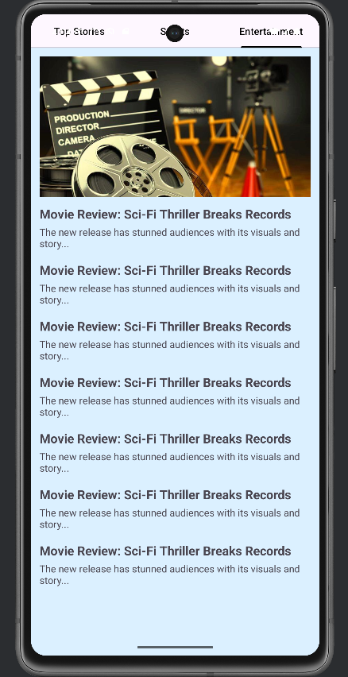
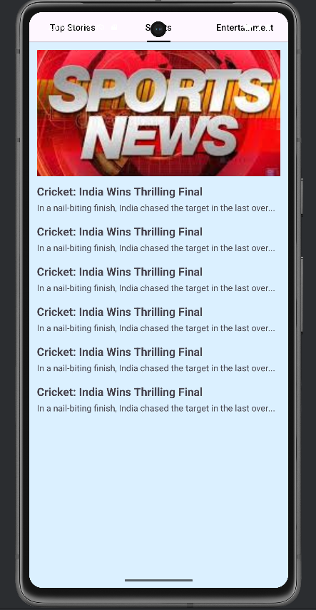
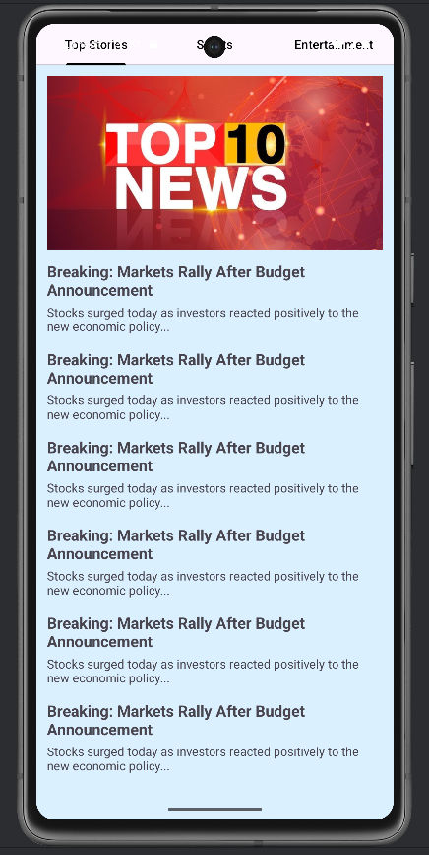

LAB 4: Input Controls in Android
Q1. Develop a "Test App" that includes a layout with a Button and a ToggleButton. When each button is clicked, a custom Toast message should be displayed with different images as their content.
activity_main.xml
<?xml version="1.0" encoding="utf-8"?>
<LinearLayout xmlns:android="http://schemas.android.com/apk/res/android"
android:layout_width="match_parent"
android:layout_height="match_parent"
android:orientation="vertical"
android:gravity="center"
android:padding="24dp"
android:background="@android:color/black">

<Button
android:id="@+id/btnShowToast"
android:layout_width="wrap_content"
android:layout_height="wrap_content"
android:text="Show Button Toast" />

<ToggleButton
android:id="@+id/toggleButton"
android:layout_width="wrap_content"
android:layout_height="wrap_content"
android:textOn="ON"
android:textOff="OFF"
android:layout_marginTop="20dp" />

</LinearLayout>

toast_layout.xml
<?xml version="1.0" encoding="utf-8"?>
<LinearLayout xmlns:android="http://schemas.android.com/apk/res/android"
android:orientation="vertical"
android:padding="12dp"
android:gravity="center"
android:layout_width="wrap_content"
android:layout_height="wrap_content"
android:background="@drawable/toast_bg">

<ImageView
android:id="@+id/toastImage"
android:layout_width="200dp"
android:layout_height="200dp"
android:scaleType="centerCrop"/>

<TextView
android:id="@+id/toastText"
android:layout_marginTop="8dp"
android:textColor="@android:color/white"
android:textSize="16sp"
android:textStyle="bold"
android:layout_width="wrap_content"
android:layout_height="wrap_content"/>
</LinearLayout>

MainActivity.java
package com.example.lab4q1;

import android.os.Bundle;
import android.view.LayoutInflater;
import android.view.View;
import android.widget.Button;
import android.widget.ImageView;
import android.widget.TextView;
import android.widget.Toast;
import android.widget.ToggleButton;

import androidx.appcompat.app.AppCompatActivity;

public class MainActivity extends AppCompatActivity {

Button btnShowToast;
ToggleButton toggleButton;

@Override
protected void onCreate(Bundle savedInstanceState) {
super.onCreate(savedInstanceState);
setContentView(R.layout.activity_main);

btnShowToast = findViewById(R.id.btnShowToast);
toggleButton = findViewById(R.id.toggleButton);

btnShowToast.setOnClickListener(v ->
showCustomToast("Button Clicked!", R.drawable.button_image)
);

toggleButton.setOnClickListener(v -> {
if (toggleButton.isChecked()) {
showCustomToast("Toggle ON", R.drawable.toggle_image);
} else {
showCustomToast("Toggle OFF", R.drawable.toggle_image);
}
});
}

private void showCustomToast(String message, int imageResId) {
LayoutInflater inflater = getLayoutInflater();
View layout = inflater.inflate(R.layout.toast_layout, null);

ImageView imageView = layout.findViewById(R.id.toastImage);
TextView textView = layout.findViewById(R.id.toastText);

imageView.setImageResource(imageResId);
textView.setText(message);

Toast toast = new Toast(getApplicationContext());
toast.setDuration(Toast.LENGTH_SHORT);
toast.setView(layout);
toast.show();
}
}
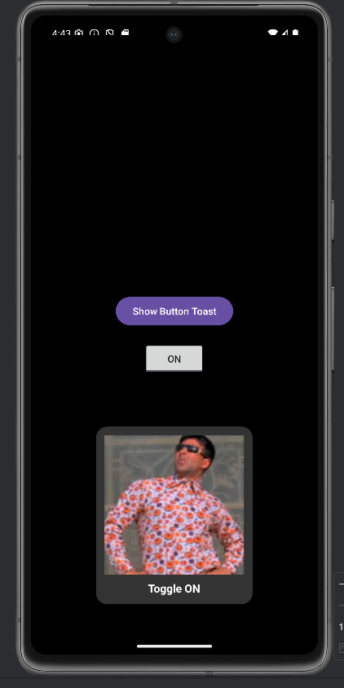
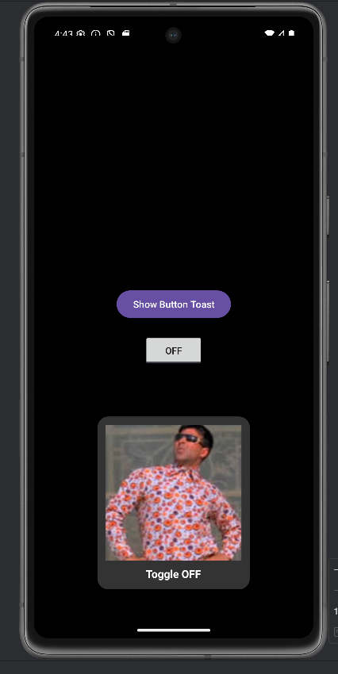
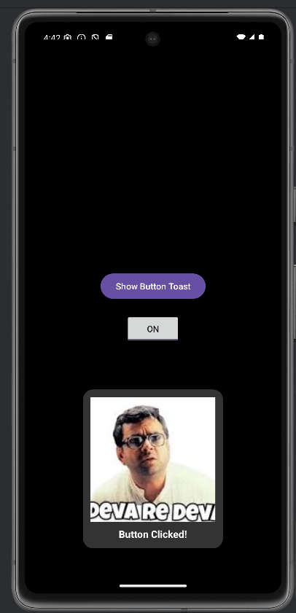

Q2. Create an app that contains a view with multiple buttons, each labeled with different Android versions. When a button is clicked, a Toast message should appear, displaying the corresponding Android version's name along with its associated icon.
activity_main.xml
<?xml version="1.0" encoding="utf-8"?>
<LinearLayout xmlns:android="http://schemas.android.com/apk/res/android"
android:layout_width="match_parent"
android:layout_height="match_parent"
android:orientation="vertical"
android:gravity="center"
android:padding="16dp"
android:background="#062e1d">
<com.google.android.material.button.MaterialButton
android:id="@+id/btnOreo"
android:layout_width="wrap_content"
android:layout_height="wrap_content"
android:text="Android Oreo"
android:backgroundTint="#9af5ce"
android:textColor="#062e1d"
android:textStyle="bold"
/>

<com.google.android.material.button.MaterialButton
android:id="@+id/btnPie"
android:layout_width="wrap_content"
android:layout_height="wrap_content"
android:text="Android Pie"
android:backgroundTint="#9af5ce"
android:textColor="#062e1d"
android:textStyle="bold"
/>

<com.google.android.material.button.MaterialButton
android:id="@+id/btnQ"
android:layout_width="wrap_content"
android:layout_height="wrap_content"
android:text="Android 10"
android:backgroundTint="#9af5ce"
android:textColor="#062e1d"
android:textStyle="bold"
/>
</LinearLayout>

toast_layout.xml

<?xml version="1.0" encoding="utf-8"?>
<LinearLayout xmlns:android="http://schemas.android.com/apk/res/android"
android:orientation="vertical"
android:gravity="center"
android:padding="12dp"
android:background="@drawable/toast_bg"
android:layout_width="wrap_content"
android:layout_height="wrap_content">
<ImageView
android:id="@+id/toastImage"
android:layout_width="170dp"
android:layout_height="170dp"
android:background="#9af5ce"/>
<TextView
android:id="@+id/toastText"
android:layout_marginTop="8dp"
android:textColor="@android:color/white"
android:textStyle="bold"
android:textSize="16sp"
android:layout_width="wrap_content"
android:layout_height="wrap_content"/>
</LinearLayout>

MainActivity.java

package com.example.lab4q2;

import android.os.Bundle;
import android.view.LayoutInflater;
import android.view.View;
import android.widget.Button;
import android.widget.ImageView;
import android.widget.TextView;
import android.widget.Toast;

import androidx.appcompat.app.AppCompatActivity;

public class MainActivity extends AppCompatActivity {

@Override
protected void onCreate(Bundle savedInstanceState) {
super.onCreate(savedInstanceState);
setContentView(R.layout.activity_main);
Button btnOreo = findViewById(R.id.btnOreo);
Button btnPie = findViewById(R.id.btnPie);
Button btnQ = findViewById(R.id.btnQ);

btnOreo.setOnClickListener(v ->
showToast("Android Oreo", R.drawable.oreo));
btnPie.setOnClickListener(v ->
showToast("Android Pie", R.drawable.pie));
btnQ.setOnClickListener(v ->
showToast("Android 10", R.drawable.android10));
}
private void showToast(String text, int imageRes) {
LayoutInflater inflater = getLayoutInflater();
View layout = inflater.inflate(R.layout.toast_layout, null);
ImageView imageView = layout.findViewById(R.id.toastImage);
TextView textView = layout.findViewById(R.id.toastText);
imageView.setImageResource(imageRes);
textView.setText(text);
Toast toast = new Toast(getApplicationContext());
toast.setDuration(Toast.LENGTH_SHORT);
toast.setView(layout);
toast.show();
}
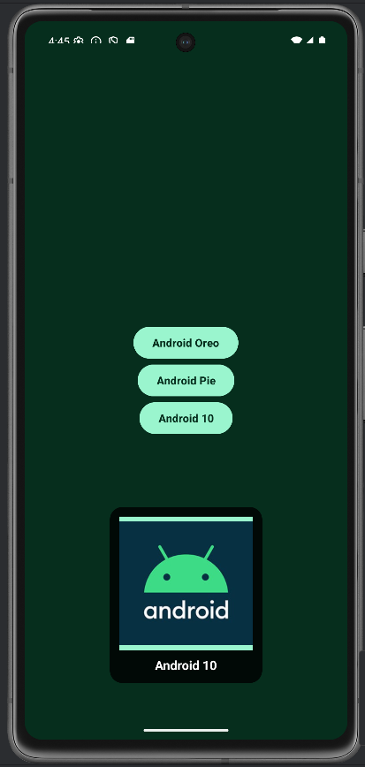
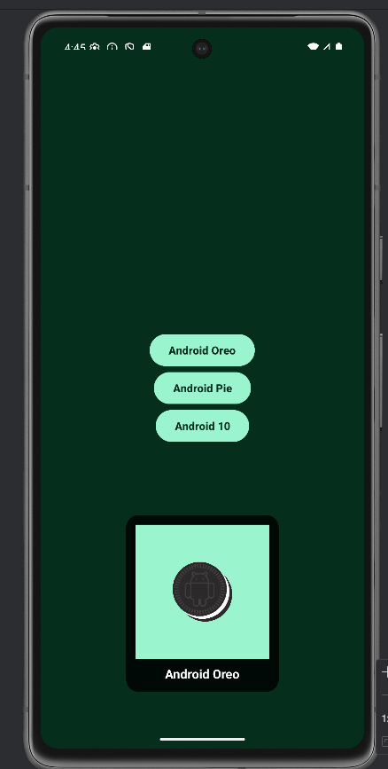
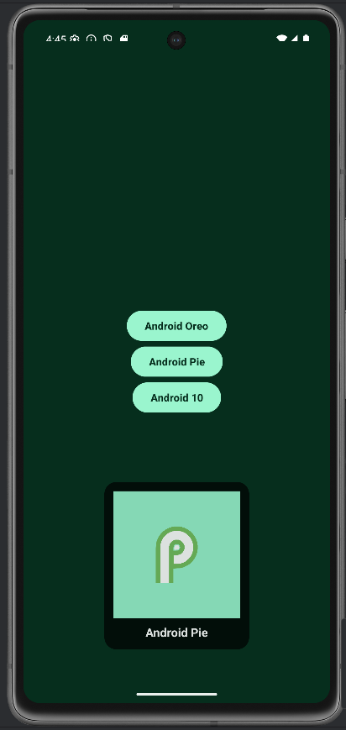
}
Q3. Develop a view with a ToggleButton labeled "Current Mode" that has two states: "Wi-Fi" and "Mobile Data." Based on the state of the toggle button, an image corresponding to the selected mode should appear, and a Toast message should display the current mode. Additionally, when the user clicks the "Change Mode" button, the app should switch to the corresponding mode and update the image accordingly.

activity_main.xml
<?xml version="1.0" encoding="utf-8"?>
<LinearLayout xmlns:android="http://schemas.android.com/apk/res/android"
android:layout_width="match_parent"
android:layout_height="match_parent"
android:orientation="vertical"
android:gravity="center"
android:padding="24dp"
android:background="#f7d2e1">

<ToggleButton
android:id="@+id/toggleMode"
android:layout_width="wrap_content"
android:layout_height="wrap_content"
android:textOff="Mobile Data"
android:textOn="Wi-Fi"
android:text="Current Mode"
android:textStyle="bold"
android:textAllCaps="false"
android:layout_marginBottom="50dp"
android:background="@color/white"/>

<ImageView
android:id="@+id/imageMode"
android:layout_width="120dp"
android:layout_height="120dp"
android:src="@drawable/wifi_icon"
android:contentDescription="Mode Icon"
android:layout_marginBottom="24dp" />

<Button
android:id="@+id/btnChangeMode"
android:layout_width="wrap_content"
android:layout_height="wrap_content"
android:layout_marginTop="50dp"
android:text="Change Mode" />
</LinearLayout>

MainActivity.java

package com.example.lab4q3;
import android.os.Bundle;
import android.widget.Button;
import android.widget.ImageView;
import android.widget.ToggleButton;
import android.widget.Toast;
import androidx.appcompat.app.AppCompatActivity;
public class MainActivity extends AppCompatActivity {
ToggleButton toggleMode;
ImageView imageMode;
Button btnChangeMode;

@Override
protected void onCreate(Bundle savedInstanceState) {
super.onCreate(savedInstanceState);
setContentView(R.layout.activity_main);

toggleMode = findViewById(R.id.toggleMode);
imageMode = findViewById(R.id.imageMode);
btnChangeMode = findViewById(R.id.btnChangeMode);

// Initialize with correct mode
updateUI(toggleMode.isChecked());
toggleMode.setOnCheckedChangeListener((buttonView, isChecked) -> {
updateUI(isChecked);
showToast(isChecked);
});
btnChangeMode.setOnClickListener(v -> {
// Toggle the button programmatically
boolean newMode = !toggleMode.isChecked();
toggleMode.setChecked(newMode); // This triggers the listener and updates UI & toast
});
}

private void updateUI(boolean isWifi) {
if (isWifi) {
imageMode.setImageResource(R.drawable.wifi_icon);
} else {
imageMode.setImageResource(R.drawable.mobile_data_icon);
}
}

private void showToast(boolean isWifi) {
String mode = isWifi ? "Wi-Fi" : "Mobile Data";
Toast.makeText(this, "Current Mode: " + mode, Toast.LENGTH_SHORT).show();
}
}
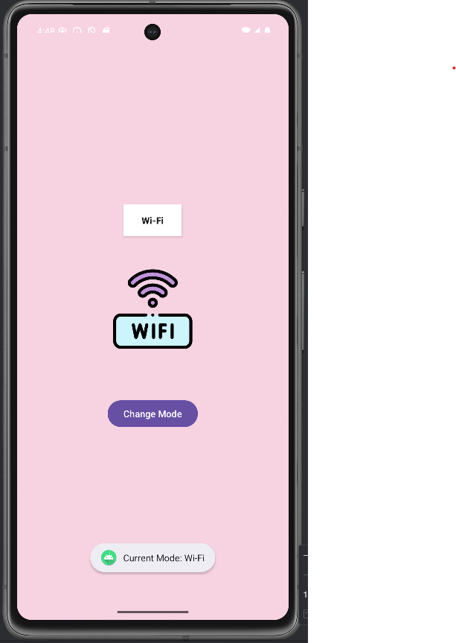
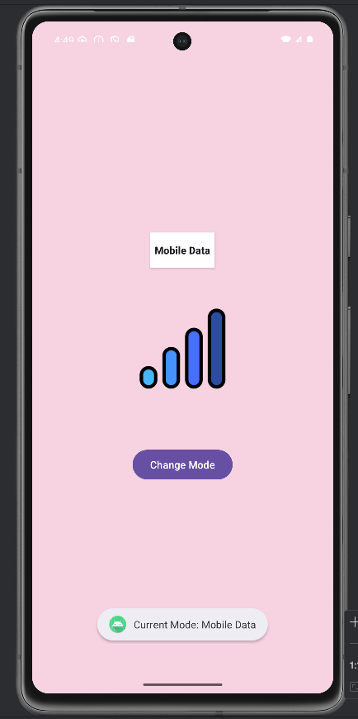

Q4. Create a “Food Ordering App” which lists food items with check boxes. Once the user checks /unchecks the item and click on the submit button display the items ordered along with cost of each item and total cost in a new activity. Once the user clicks on the submit button he/she should not be allowed to change the order i.e. he should not be allowed to change the state of the items checked.
activity_main.xml
<?xml version="1.0" encoding="utf-8"?>
<ScrollView xmlns:android="http://schemas.android.com/apk/res/android"
android:layout_width="match_parent"
android:layout_height="match_parent">

<LinearLayout
android:layout_width="match_parent"
android:layout_height="wrap_content"
android:orientation="vertical"
android:padding="24dp">

<!-- 🔹 Heading at the TOP -->
<TextView
android:id="@+id/txtTitle"
android:layout_width="wrap_content"
android:layout_height="wrap_content"
android:text="Select your order!"
android:textSize="22sp"
android:textStyle="bold"
android:layout_marginBottom="16dp"/>

<!-- 🔹 Food Items will be added here -->
<LinearLayout
android:id="@+id/foodContainer"
android:layout_width="match_parent"
android:layout_height="wrap_content"
android:orientation="vertical"/>

<!-- 🔹 Submit Button -->
<Button
android:id="@+id/btnSubmitOrder"
android:layout_width="wrap_content"
android:layout_height="wrap_content"
android:text="Submit Order"
android:layout_marginTop="24dp"/>
</LinearLayout>

</ScrollView>

activity_summary.xml
<?xml version="1.0" encoding="utf-8"?>
<ScrollView xmlns:android="http://schemas.android.com/apk/res/android"
android:layout_width="match_parent"
android:layout_height="match_parent">

<LinearLayout
android:id="@+id/summaryRoot"
android:layout_width="match_parent"
android:layout_height="match_parent"
android:orientation="vertical"
android:gravity="center"
android:padding="24dp">

<!-- 🔹 Heading -->
<TextView
android:id="@+id/txtHeading"
android:layout_width="wrap_content"
android:layout_height="wrap_content"
android:text="Order Summary"
android:textSize="26sp"
android:textStyle="bold"
android:layout_marginBottom="24dp"/>

<!-- 🔹 List container -->
<LinearLayout
android:id="@+id/summaryContainer"
android:layout_width="match_parent"
android:layout_height="wrap_content"
android:orientation="vertical"/>

</LinearLayout>

</ScrollView>

MainActivity.java

package com.example.lab4q4;
import com.example.lab4q4.FoodItem;
import com.example.lab4q4.SummaryActivity;

import android.content.Intent;
import android.os.Bundle;
import android.widget.Button;
import android.widget.CheckBox;
import android.widget.LinearLayout;
import android.widget.Toast;
import androidx.appcompat.app.AppCompatActivity;
import java.util.ArrayList;

public class MainActivity extends AppCompatActivity {
LinearLayout foodContainer;
Button btnSubmitOrder;
ArrayList<FoodItem> foodList;
ArrayList<CheckBox> checkBoxes;
boolean orderSubmitted = false;

@Override
protected void onCreate(Bundle savedInstanceState) {
super.onCreate(savedInstanceState);
setContentView(R.layout.activity_main);

foodContainer = findViewById(R.id.foodContainer);
btnSubmitOrder = findViewById(R.id.btnSubmitOrder);

checkBoxes = new ArrayList<>();

// Sample food items
foodList = new ArrayList<>();
foodList.add(new FoodItem("Pizza", 8.99));
foodList.add(new FoodItem("Burger", 5.49));
foodList.add(new FoodItem("Pasta", 7.99));
foodList.add(new FoodItem("Salad", 4.50));
foodList.add(new FoodItem("Ice Cream", 3.25));

// Add checkboxes dynamically
for (FoodItem item : foodList) {
CheckBox cb = new CheckBox(this);
cb.setText(item.name + " - $" + String.format("%.2f", item.price));
foodContainer.addView(cb);
checkBoxes.add(cb);
}

btnSubmitOrder.setOnClickListener(v -> {
if (orderSubmitted) {
Toast.makeText(this, "Order already submitted. Cannot change.", Toast.LENGTH_SHORT).show();
return;
}

ArrayList<String> orderedItems = new ArrayList<>();
ArrayList<Double> prices = new ArrayList<>();
double totalCost = 0;

for (int i = 0; i < checkBoxes.size(); i++) {
CheckBox cb = checkBoxes.get(i);
if (cb.isChecked()) {
FoodItem fi = foodList.get(i);
orderedItems.add(fi.name);
prices.add(fi.price);
totalCost += fi.price;
}
}

if (orderedItems.isEmpty()) {
Toast.makeText(this, "Please select at least one item.", Toast.LENGTH_SHORT).show();
return;
}

// Disable all checkboxes and button after submission
for (CheckBox cb : checkBoxes) {
cb.setEnabled(false);
}
btnSubmitOrder.setEnabled(false);
orderSubmitted = true;

// Pass data to SummaryActivity
Intent intent = new Intent(MainActivity.this, SummaryActivity.class);
intent.putStringArrayListExtra("orderedItems", orderedItems);
intent.putExtra("prices", prices);
intent.putExtra("totalCost", totalCost);
startActivity(intent);
});
}
}

FoodItem.java

package com.example.lab4q4;
public class FoodItem {
public String name;
public double price;
// ✅ Constructor that matches: new FoodItem("Pizza", 8.99)
public FoodItem(String name, double price) {
this.name = name;
this.price = price;
}
}

SummaryActivity.java

package com.example.lab4q4;
import android.os.Bundle;
import android.widget.LinearLayout;
import android.widget.TextView;
import androidx.appcompat.app.AppCompatActivity;
import java.util.ArrayList;
public class SummaryActivity extends AppCompatActivity {
LinearLayout summaryContainer;
@Override
protected void onCreate(Bundle savedInstanceState) {
super.onCreate(savedInstanceState);
setContentView(R.layout.activity_summary);
summaryContainer = findViewById(R.id.summaryContainer);
ArrayList<String> orderedItems = getIntent().getStringArrayListExtra("orderedItems");
ArrayList<Double> prices = (ArrayList<Double>) getIntent().getSerializableExtra("prices");
double totalCost = getIntent().getDoubleExtra("totalCost", 0);
if (orderedItems == null || prices == null) return;
for (int i = 0; i < orderedItems.size(); i++) {
String item = orderedItems.get(i);
Double price = prices.get(i);
TextView tv = new TextView(this);
tv.setText(item + " - $" + String.format("%.2f", price));
tv.setTextSize(18);
tv.setPadding(0, 8, 0, 8);
summaryContainer.addView(tv);
}
// Total cost
TextView totalView = new TextView(this);
totalView.setText("Total Cost: $" + String.format("%.2f", totalCost));
totalView.setTextSize(22);
totalView.setPadding(0, 24, 0, 0);
summaryContainer.addView(totalView);
}
}

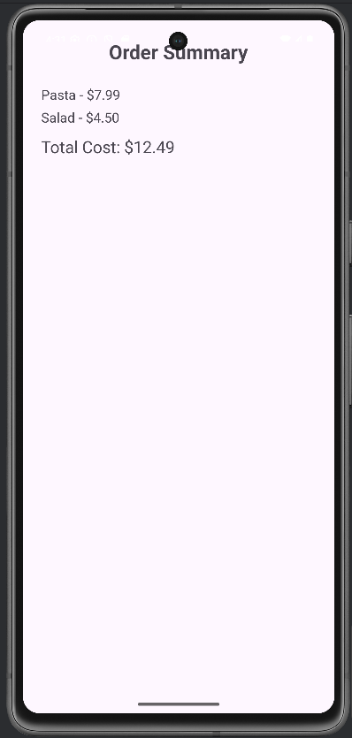
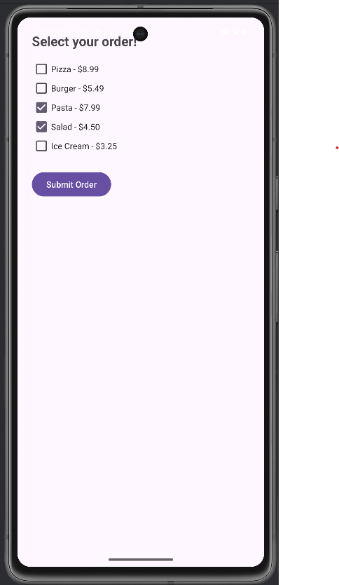

Submitted By: Tanisha Mathur
Reg. No.: 230953110
CCE: B, Roll No.: 17

